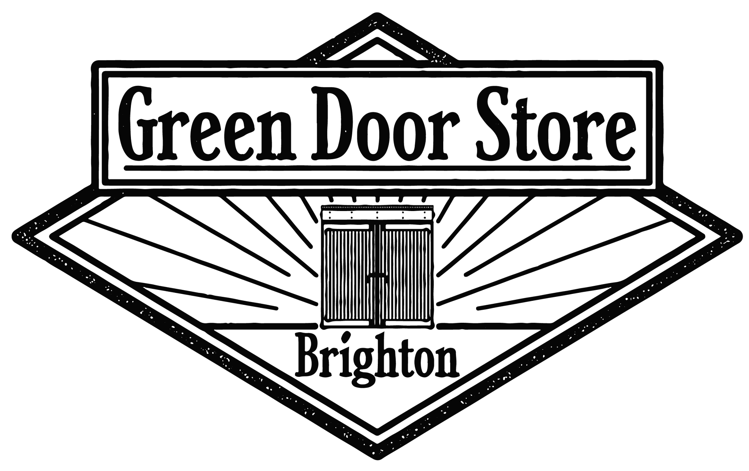

Promoter Terms & Conditions Document 2026

This document outlines our terms and conditions for external promoters booking shows at The Green Door Store. When confirming your show with us you are agreeing to abide by our terms & conditions, of which are legally binding.
We reserve the right to cancel a show should the promoter not follow what has been outlined in this document.
Venue & Contact Info
The Green Door Store, Trafalgar Arches, Lower goods yard, Brighton Railway Station BN1 4FQ
http://www.thegreendoorstore.co.uk
http://www.facebook.com/greendoorstore
http://www.twitter.com/greendoorstore
http://www.instagram.com/greendoorstore

Head Office
info@thegreendoorstore.co.uk

Venue Contacts
Production & Programming Manager
Angel
Email: Angel@thegreendoorstore.co.uk

Production & Programming Assistants
Leila
Email: Leila@thegreendoorstore.co.uk
Alfie
Email: Alfie@thegreendoorstore.co.uk

Access
Email: access@thegreendoorstore.co.uk
Lost Property
Email: lostproperty@thegreendoorstore.co.uk
Location
We are located directly underneath Brighton Railway Station.
By foot: via Trafalgar Street or Cheapside/Fleet Street/New England Street.
By car: From Cheapside/New England Road. There is no access by car via Trafalgar Street.
Please see map below:
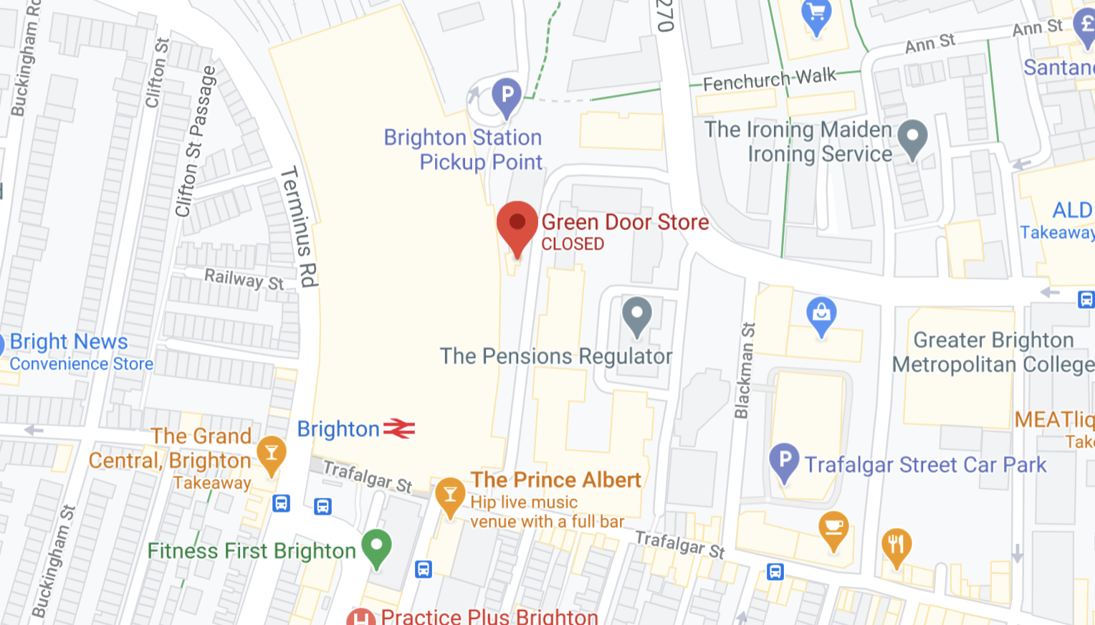

Access
Please contact us in advance of the show if any of your artists, staff or audience members have access needs. We also ask that you provide Large print stage times in advance of the show, where possible.

Blue Badge Parking:
https://bluebadgeparking.com/view/50.822713%2C-0.151509%2C50.839573%2C-0.08971/road#.YC1ByhP7TJ8
Standard Parking
There is no parking available at the venue. We recommend parking at:
Trafalgar St Car Park, BN1 4DZ.

Load-in
Load-in begins at 1700 unless otherwise arranged in advance. If a sound engineer is required prior to 1700 for an early sound-check then there is an additional fee of £20ph.

Please be aware that due to noise restrictions, amplified music is not permitted at the venue prior to 1700 Mon-Fri. You are welcome to load-in early and set up the stage/merch etc, but soundchecks are not to begin until 1700 on weekdays.
Only our in-house sound engineer is permitted to access the sound desk and use our in- house equipment and PA. You are welcome to bring your own sound engineer but they will be monitored by ours.

Any damages caused by misuse of any of our equipment will be charged to the promoter and/or artist.

Sun-Thurs events must finish no later than 22.30 unless by prior arrangement.

**On Friday’s/Saturday’s live curfew is 22:15pm allowing extra time for our club night changovers.**

Accessibility
We have a dedicated access email. (access@thegreendoorstore.co.uk) Please feel free to share this with your customers if they have questions about access. Our venue is a one-level space and fully accessible although we do advise you to make customers aware that we are a Grade II listed building with cobbled flooring. If you require any additional assistance for yourself or your artists and customers, please make a staff member aware. We need a minimum of 5 days notice of any specific access requirements.

In an attempt to ensure that the needs of our customers are being met we would love it if you would implement a refund policy for anybody with accessibility issues that cannot attend an event due to health reasons. This is something that other fully accessible venues are also implenting in order to improve the way accessibility needs are handled.

This is only something we are asking you to consider for people with accessibility issues.

Gender Neutral Toilets
Please be aware that we have 1 gender neutrel toilet and one female/queer/trans inclusive toilet. But we also have gender neutral signs for both toilets for any event who wishes to request both toilets be gender neutrel for their event.

You may wish to make your audience aware in advance. We also have an accessible toilet accessed with the use of a Radar key.

Important Parking Information
There is no parking at the venue overnight unless arranged prior to the event.

Cancellation Policy
Once we receive confirmation for a date, if this is then cancelled within 8 weeks you will be charged a £160 cancellation fee. If we have incurred any print fees then we will also ask that these are reimbursed.

Any event that has been confirmed through a date challenge is then cancelled, will incur a cancellation fee regardless of of the 8 week period mentioned above.

If you choose to reschedule your date, you can be relieved of the cancellation free, provided you officially confirm a new date within 4 weeks of the cancellation date. While the new show itself can take place up to 6 months after the original date, the booking must be finalised within that initial 4-week window. Failure to confirm a new date within 4 weeks will result in a cancellation fee.

We reserve the right to cancel any event that has not followed the Terms & Conditions of this document.

GDS is a safe space for everyone to enjoy live music and part of our core morals as a live music venue. If we are made aware of any behaviours that are not inline with what we expect from anyone being part of an event in the venue (e.g. abuse, harassment, sexism, racism, homophobia, transphobia) from any parties involved that we reserve the right to remove said show/person in question from operating at the venue.

We also reserve the right to cancel your gig if proceeding with the event could compromise our duty of care or negatively impact our reputation.

Working With Promoters

In order for all events to be beneficial to all parties involved e.g. venue, promoter, artists, audience. Our team will work alongside you as a promoter to ensure that all the events are crafted to successful standard which means our in-house booking team will liaise with you regarding, line-ups, ticket pricing, timings, marketing.

We are always happy to help out our external promoters with suggestions for shows and our team reserves the right to suggest any changes to your event that they seem fit to ensure your event is a success in our establishment.

Upgrading Venue
Should you choose to ‘upgrade venue’ and wish to pull out of your confirmed date at the Green Door Store, you will be charged £160 as a cancellation fee. This is non negotiable.

Carer/Budding System

We expect all of our promoters to offer a carer/buddy ticket free-of-charge for customers who need additional access. The requests for these tickets are not frequent and we do not expect it to effect your show budget. If you have concerns then please contact us.

Wheelchair Users

Please be aware that we have space for two wheelchair users in the live room. Our staff will be able to accommodate these customers with access to and from the two available spaces. You may find it helpful to sell these tickets as ‘Wheelchair Access Tickets’.

Please ensure you provide this access information at the point of sale.
Travel
Taxi: We recommend Streamline Taxis, please specify directly outside the venue if unloading: 01273 202020 Bicycle: There are no bicycle docks at Brighton Train Station. Rail: We are located directly under Brighton Train Station for direct connection to London and most of Southern England.
Coach: Pool Valley coach station is a 10 minute walk away. Bus: All buses serving Brighton station are less than a minutes walk away. Air: Gatwick Airport is 30 minutes by train. All other London airports are easily accessible.

Opening Times
We hold a 24 hour license. The bar area is opened at 1900 daily and is always free to enter. We host two events on Fridays, Saturday and Bank Holiday Sundays; An early show that runs from 1900-2230 and a late show from 2300-0400. We occasionally hold late night events on Tuesdays/Thursdays.
We are available for daytime events on request; private parties, filming, photo- shoots, festivals etc. This is charged at £70 for 3 hours or £140 for 6 hours.
If you need to access our PA and/or lighting system then we will require you to book a in-house sound engineer for the duration of the shoot at a fee of £18ph.

Capacity
We function as a 300 person capacity venue. The recommended total capacity for our live room is 170. Events are normally ticketed to 150 taking guests/band members into consideration.
There is a maximum house guest list of 10 people per event. We reserve the right to add press and photography contacts to this list. We will inform you of any press/photography attending prior to the show.

Please be aware that all of our staff can enter all events free of charge. This will not be included in your overall selling capacity.
Equipment
Our venue spec is available on request. We have backline that is hireable upon request. Backline hire must be requested to us minimum 5 days prior to your event.

Guitar Amps: £20 (per amp)
2 x Marshall MG50FX's

Bass Amp: £20
1 x Fender Rumble Bass Amp
Drum kit hire: £60
Natal Arcadia Series Drum Shells
Cymbal Stands
Drum Stool
**Drummers must provide their own breakable**
We also recommend Ooosh Touring for any additional backline hire: 01273 911 382.

Smoke Machines

The use of smoke machines, or any other smoke/haze/dry ice systems or mechanisms is not permitted at the venue. Please be aware this rule applies to all smoke machines (etc.) used at the venue, so bands cannot bring their own as an alternative.

Advancing
Please send the following information no later than two weeks before the event to our production team:
- Tech specs for all artists
- Load-in timings (if not standard)
- Sound-check timings
- Set timings
- Latest ticket count
Promotion
Please send the following information for our press, listings & website at point of confirmation:
• Facebook event
• Online ticket link
• Web-ready artwork
• Full line up
• Announcement date
•Press release (where applicable)
Please send us 5 x A3 posters to put up inside of the venue. We also have a flyer rack. Flyposting, (including stickers) is illegal. All charges resulting from flyposting will be passed on to the promoter.

Ticketing
When ticketing for your event these are our outlined ticket capacity for events.
Gigs - 150 Tickets
Club Nights - 300 Tickets + Tickets on the door
All Dayer - 200 Tickets + Tickets on the door
If you decide to sell tickets under our guidelines of capacity for events we reserve the right to charge you an attendees average spend of £20 per ticket you have refused to sell.
**Please note this does not mean if you don’t sell out a show at 150 tickets that you will be charged per head. This is only if you choose to not sell tickets too capacity and have not discussed this with us.**
If you do not meet a minimum of 30 tickets sold for your event we reserve the right to remove the show, to ensure that the venue is not put in a vulnerable situation.
We do not handle ticketing in house. We recommend ticketing through:

Ticketpass

Ticketpass provides an ethical alternative to the ticketing industry. Their platform is an all-in-one solution for creating events, buying and selling tickets, live streaming and keeping events a safe space.

https://ticketpass.org/

Other

You are welcome to provide rider for your artists, provided you stick to canned beers, ciders and soft drinks.
Any glass bottle alcohol or spirits are stricly prohibited inside the venue and glass bottles or spirits bought into the venue will be confiscated from your rider and returned to you at the end of the night.
We do not have a dressing room. There is a curtained area next to the stage.
If you require a box office staff, please request in advance. The cost is charged at £14 per hour for a minimum of 4 hours.

These must be officially requested to use via email, please do not send us an advance assuming that we will arrange box office.

**All promoters are expected to provide a show rep for their show.**
We can provide a cash float for your event but this must be requested in advance.
We do not provide promoters with a card reader in-house so please ensure you bring a card reader for your event.
We are a strictly 18+ venue. Under no circumstances can an event be marketed as an under 18s event. Please ensure you include ‘18+’ on any promotional material.

Hire Info
What is included in the hire fee:
• 170 standing capacity in the live room. (300 capacity throughout only applicable to club nights).
• Full use of PA and lighting
• 1x Sound Engineer from 5PM
What is not included in the hire (additional charge)
• Box office staff/rep
• In-house DJ or Live Music
• Security
• Catering
Please be aware that there will be an increase in hire fees every April, in line with the government's minimum hourly rate increases. Unfortunately, this increase will be added to hire fees for shows confirmed prior to the increase. We will always be transparent with our fees and aim to keep them as low as possible.
Invoicing
All new promoters are expected to pay their event via invoice atleast 1 week prior to the event happening.
Security
All our door staff are SIA registered and work regularly at the venue so are aware of our policies and procedures.
If we are required security for an event wether it be at our request or the promoters, this charge will be passed on to the promoter of the event. Security is charged at £26 per hour for a minimum of 4 hours.
Additional qualifications obtained by our Management staff
Trans Awareness Training
Mental Health First Aid
AIE Disability Equality Training
Spiking Awareness Training

