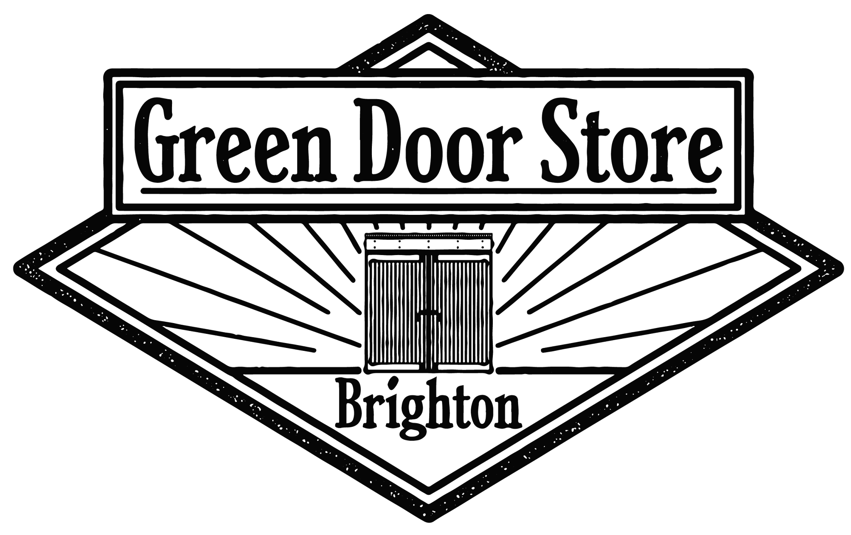

Venue Technical Specifications 2026

Desk
Allen & Heath SQ7 w/ Add ons : MultiBD, DynEQ4, De-Esser, Tube Stage.

Speakers
4x Turbosound TCS56 bi-amped
2x Wembley double 18” bass bins
DAS Audio DSP-226 Crossover/LSMS

Monitors
4x Martin Audio LE400 (Beyma loaded)
Analogue Multicore
1x 16/4
1x 16/8
Boxes situated at either end of the stage. Configurable up to 32 channels + 12 returns
Digital Multicore
3x CAT5e S/FTP install terminating at sockets situated at booth and stage
2x 4m CAT5e S/FTP patch cables

Backline: For backline hire costs, please contact:info@thegreendoorstore.co.uk

Guitar Amps: 2 x Marshall MG50FX's

Bass Amp: 1 x Fender Rumble Bass Amp

Drum kit hire: Natal Arcadia Series Drum Shells / Cymbal Stands / Drum Stool **Drummers must provide their own breakables**

Cables/ Stands
35x Neutrik XLR cables
6x K&M tall fixed boom stands
1x K&M tall telescopic boom stand
5x K&M half height telescopic boom stands
1x K&M chrome upright (solid base)

Mic’s
7x Shure SM58
4x Shure SM57
1x Sontronics Solo
1x Sennheiser e602
6x Sennheiser e904
2x Sennheiser e609
1x Shure PG81
2x Beyer TG I53

DI’s
4x BSS AR133 active
1x EMO System E520 passive
1x EMO System E525 dual passive
Lighting
Chamsys PC Wing and MagicQ on Dell touchscreen laptop
12x Cameo CLPST64Q8W RGBW PAR64
3x Cameo CLP64RGBWAU12W PAR64
4x Cameo CLROOTPAR6 RGBWAU
2x Optikinetics Super Slave Strobe + Control 1
Stairville AF-150 Fogger
Mirror Ball & Spot

Video
1x Epson EH-TW740 1920x1080 3LCD Projector (Live Room)
1x Epson EH-TW740 1920x1080 3LCD Projector (Bar Area)
1x Kramer VM-114H4C HDMI & CAT5 to CAT5 receiver/transmitter/splitter
1x Kramer PT-571 HDMI to CAT5 transmitter (stage)
2x Connectix S/FTP CAT5e cable from stage to booth. Sockets situated
in the amp rack at stage right. Assorted adapters (enquire for specifics)

Stage specification
4.9m width x 2.7m depth x 0.60m height

For all technical inquiries, email: info@thegreendoorstore.co.uk

Dressing Room
The dressing room is a one-level access, curtained off area, to stage left.

Stage
We have two user-friendly wooden steps up to the main stage area. These
are outlined with hazard tape to assist the user.

There is no level access to the stage. Please contact us if you or others
require assistance to utilise the stage.

